
UCS301 Data Structures - Lab Assignment 3
Submitted by: DISHITA BANSAL, Roll No. 1024030365, Batch:2C24

Develop a menu driven program demonstrating the following operations on a Stack using array: (i) push(), (ii) pop(), (iii) isEmpty(), (iv) isFull(), (v) display(), and (vi) peek().
#include <iostream>
using namespace std;
#define MAX 5

int stack[MAX], top = -1;

void push(int x) {
if (top == MAX - 1)
cout << "Stack Overflow!\n";
else {
stack[++top] = x;
cout << x << " pushed.\n";
}
}

void pop() {
if (top == -1)
cout<<"Stack Underflow\n";
else
cout<<stack[top--]<<"popped.\n";
}

void peek() {
if (top == -1)
cout<<"Stack is Empty\n";
else
cout<<"Top element:"<<stack[top]<< endl;
}

void display() {
if (top == -1)
cout <<"Stack is Empty\n";
else {
cout << "Stack: ";
for (int i = top; i >= 0; i--)
cout << stack[i] << " ";
cout<<endl;
}
}

int main() {
int choice, value;
do {
cout<<"\n--- Stack Menu ---\n";
cout<<"1. Push\n2. Pop\n3. isEmpty\n4. isFull\n5. Display\n6. Peek\n7. Exit\n";
cout<<"Enter choice: ";
cin>>choice;

switch(choice) {
case 1:
cout<<"Enter value: ";
cin>>value;
push(value);
break;
case 2:pop();
break;
case 3:
cout<<(top == -1 ? "Stack is Empty\n" : "Stack is NOT Empty\n");
break;
case 4:
cout<<(top == MAX - 1 ? "Stack is Full\n" : "Stack is NOT Full\n");
break;
case 5:display();
break;
case 6:peek(); break;
case 7:cout<<"Exiting\n";
break;
default:cout<<"Invalid choice!\n";
}
} while(choice != 7);

return 0;
}
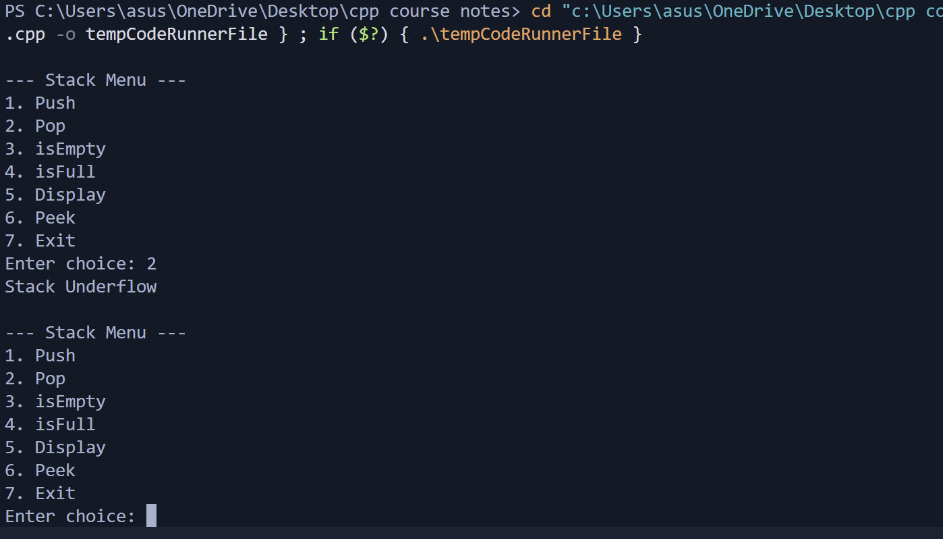
Given a string, reverse it using STACK. For example “DataStructure” should be output as “erutcurtSataD.”
#include <iostream>
using namespace std;

int main() {
char str[100], stack[100];
int top = 1;

cout<<"Enter a string: ";
cin >> str;

// push
for(int i=0;str[i]!='\0'; i++) {
stack[++top] = str[i];
}
cout<<"Reversed string: ";
while(top != -1) {
cout<<stack[top--];
}

return 0;
}

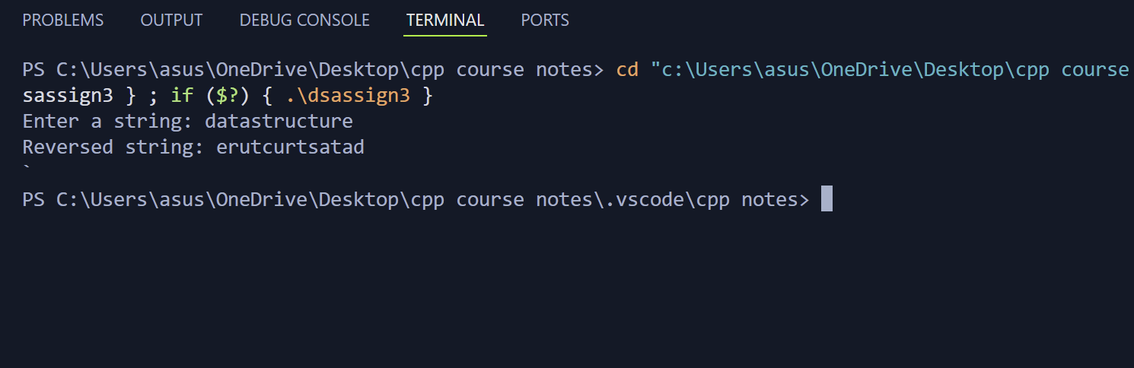

3. Write a program that checks if an expression has balanced parentheses.
#include <iostream>
using namespace std;

char stack[100];
int top = -1;

void push(char c) {
stack[++top] = c;
}

char pop() {
if (top == -1) return '\0';
return stack[top--];
}

bool isBalanced(string exp) {
for (int i = 0; exp[i] != '\0'; i++) {
char ch = exp[i];

if (ch == '(' || ch == '{' || ch == '[') {
push(ch);
}

else if (ch == ')'||ch=='}' || ch == ']') {
if (top == -1) return false;

char popped = pop();
if ((ch==')'&& popped!='(') ||
(ch=='}'&&popped!='{') ||
(ch==']'&& popped!='[')) {
return false;
}
}
}

return (top == -1);
}

int main() {
string expr;
cout<<"Enter expression: ";
cin>>expr;

if(isBalanced(expr))
cout<<"Balanced\n";
else
cout<<"Not Balanced\n";

return 0;
}

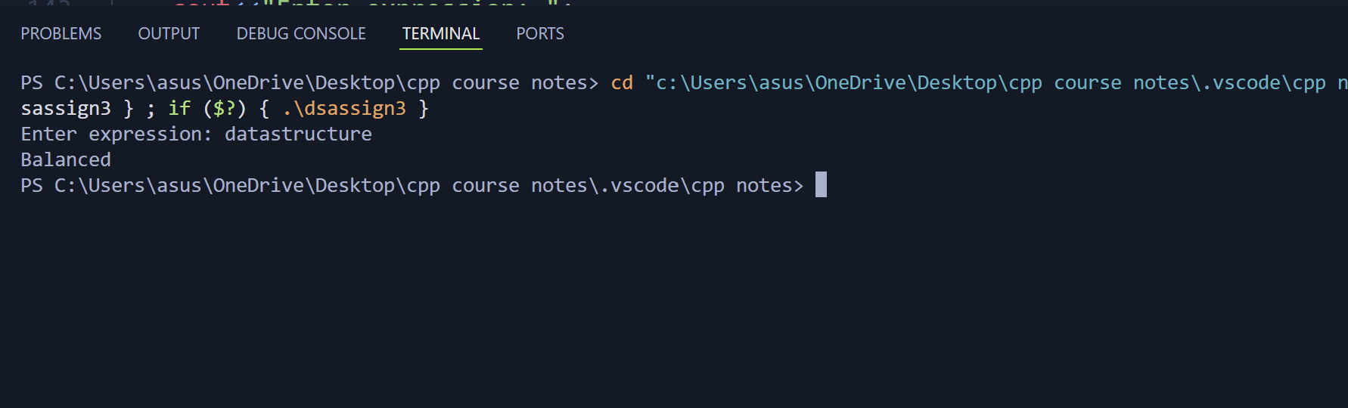
Write a program to convert an Infix expression into a Postfix expression.
#include <iostream>
#include <stack>
using namespace std;

int main() {
string exp;
cin>>exp;
stack<int> s;

for(char c:exp) {
if(isdigit(c)) {
s.push(c-'0');
} else {
int b=s.top();
s.pop();
int a=s.top();
s.pop();
if(c=='+') s.push(a+b);
else if(c=='-') s.push(a-b);
else if(c=='*') s.push(a*b);
else if(c=='/') s.push(a/b);
}
}
cout<<s.top();
return 0;
}
